PreventT2 Participant Information
For program use only:
Participant ID ___________________

Name ______________________________________________________ DOB_____________________
Height ________ ft. ________ in. Gender □ Male □ Female
Primary Phone Number ______________________________
Secondary Phone Number ______________________________
Email address (optional) ________________________________________________________________

Have you been diagnosed with prediabetes?
□ Yes □ No
If you have been diagnosed with prediabetes by your physician, please fill out the following information:
Physician Name ________________________________________________________________________
Physician Practice Name _________________________________________________________________
For Females Only
Were you diagnosed with gestational diabetes during any of your pregnancies?
□ Yes □ No

Did you take the prediabetes risk assessment before enrolling? □ Yes □ No □ N/A
If so, did the assessment state you were at risk?
□ Yes □ No □ N/A
PreventT2 Program Commitment
I, _______________________________________________, hereby promise to be committed to making a lifestyle change. I’m making this commitment to myself and __________________________________ to make ___________ the year I develop better habits to help prevent or reduce my risk of developing type 2 diabetes. I recognize the benefits to my health and commit to participating in every session to the best of my abilities. I understand that I must attend a minimum of 12 sessions in order to participate in the program. Signing this contract and making the commitment to participate in PreventT2 means that I will live a healthier life and be provided the chance to spend more time__________________________
____________________________________________________________________________________.
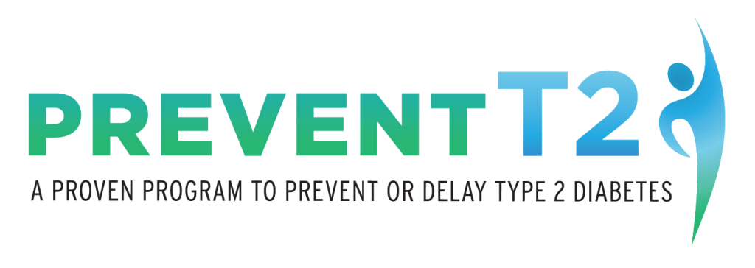
Participant Signature ____________________________________________ Date ___________________

